

RISK GAME (BUILD-1)

ARCHITECTURAL DESIGN

Advanced Programming Practices

SOEN 6441
Fall-2019

Team: Group_U_J

Mehul Prajapati (40076930)
Komal Panchal (40130791)
Maryam Giahi (40016260)
Mahmoudreza Entezami (40058782)
Parth Patel (40081116)
Shubham Ranadive (40083991)

Coding Conventions

- Code Layout
- To minimize the length and maximize the readability of the code, the curly braces are appended to the statement preceding it.
- Blank lines are added to separate sections or components to increase the readability.

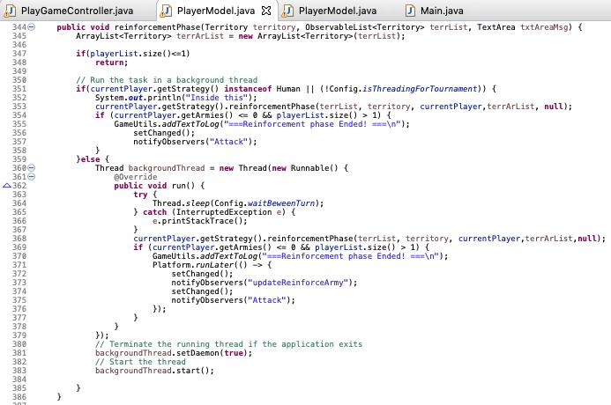

- Naming Conventions

  - Class name:
- The class names are written as the first letter as the uppercase of each word.
- Example:
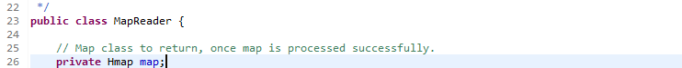

  - Function name:
- Each function name is started with the lower case, followed by the uppercase of first letter of other words to bifurcate between the words.
- Example:
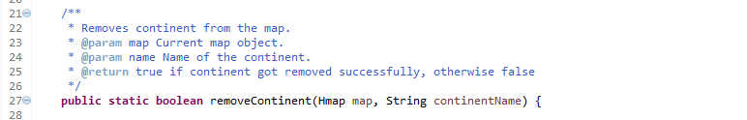

  - Variable name:
- Constant variables is started with all uppercase with words separated by underscores (“_”).
- Example:
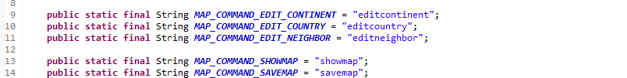

  - Folder and Package names:
- All folder and package names are written in lowercase.
- Example:
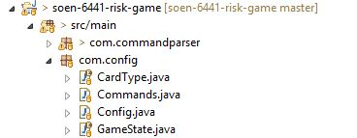

- Comments
- Commenting is done as per conventions for Java Doc.
- Each class declaration precedes by a comment explaining what the class is for.
- Each method or function have comments explaining what it does, as well as what is the purpose of parameters and return type description if the method’s return is non-void.

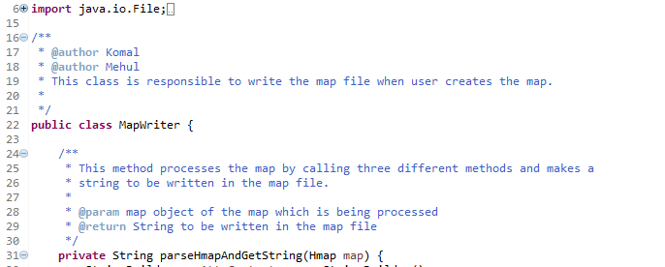

- “commented out” code:
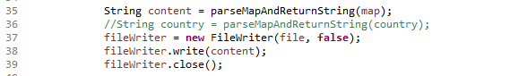

- Indentation

- Code is indented according to its nesting level to improve code readability. Indentation of the body of the function is done with respect to its header. Similarly, for the for, while, switch, if and other statements, it is done with respect to its first line.

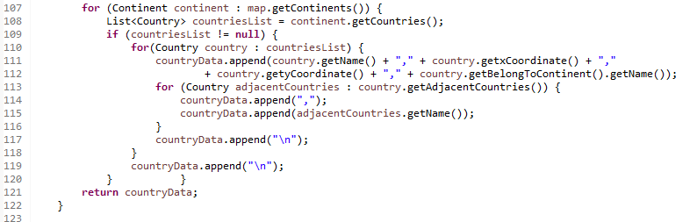

- Exception Handling
- Exception handling is done using InvalidMap class file
- User defined exception can be defined using this class.

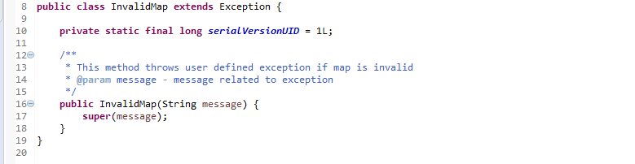

References:

- https://www.geeksforgeeks.org/java-naming-conventions/

- https://google.github.io/styleguide/javaguide.html#s6.2-caught-exceptio

